**NETAJI SUBHAS UNIVERSITY OF TECHNOLOGY**



Database Management Systems

ICCSC09

**School Management System**

| **Submitted to** | **Submitted by** | |
| --- | --- | --- |
| Mrs. Sushma Nagpal | Tanish Saxena | 2022UIC3511 |
|  | Manas Madan | 2022UIC3533 |
|  | Ayush Arora | 2022UIC3538 |

**Description**

In our school management system project, we're developing a platform that includes various entities crucial for effective school administration. These entities encompass Students, Parents, Teachers, Student Phone Numbers, Attendance Records, Results, Exams, Classrooms, Courses, and Grades. Our frontend design focuses on providing students with access to their personal data, enabling them to view their academic progress and related information. Additionally, teachers have access to their own data, as well as information pertaining to their classes and attendance records. Moreover, we're implementing a data administrator role responsible for refining and maintaining the system's database, ensuring data accuracy, security, and integrity across all functionalities.

**Problem Statement**

1. The School Management System (SMS) aims to streamline administrative tasks, enhance communication between stakeholders, and improve overall efficiency in school operations.
2. The system comprises several key entities, including students, parents, teachers, attendance records, genders, classrooms, classroom-student associations, courses, exams, and results.
3. Each entity is characterized by specific attributes, such as student names, addresses, genders, parent details, teacher information, attendance statuses, classroom locations, course descriptions, exam dates, and result grades.
4. Data integrity is maintained through proper entity relationships and constraints, preventing inconsistencies and errors in the system.

**ER Diagram**

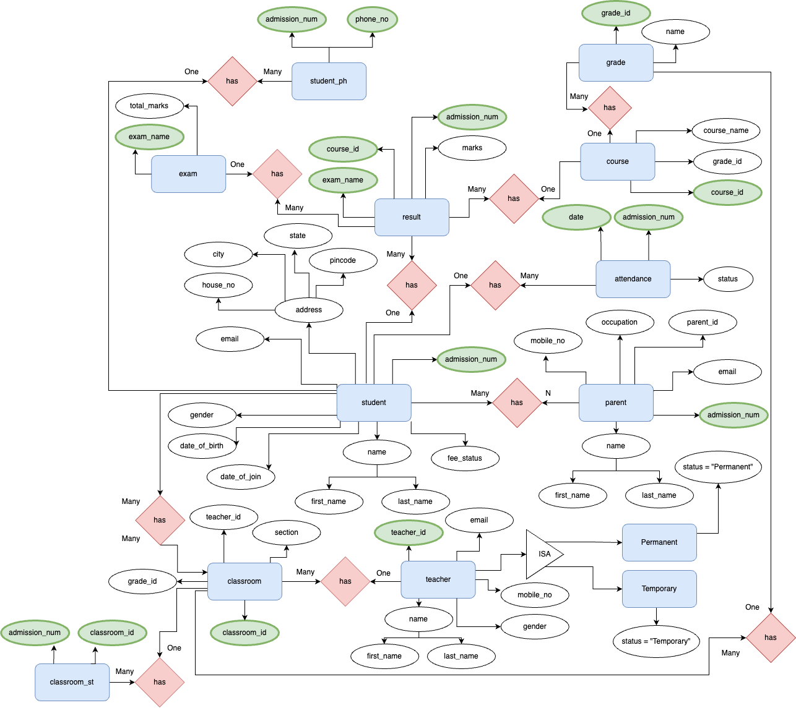

**ER Diagram to Relational Model**

